Middle School Club Descriptions

Play Performance Club: An opportunity for students who enjoy acting to come together once a week and work towards a play performance. This is a commit club.
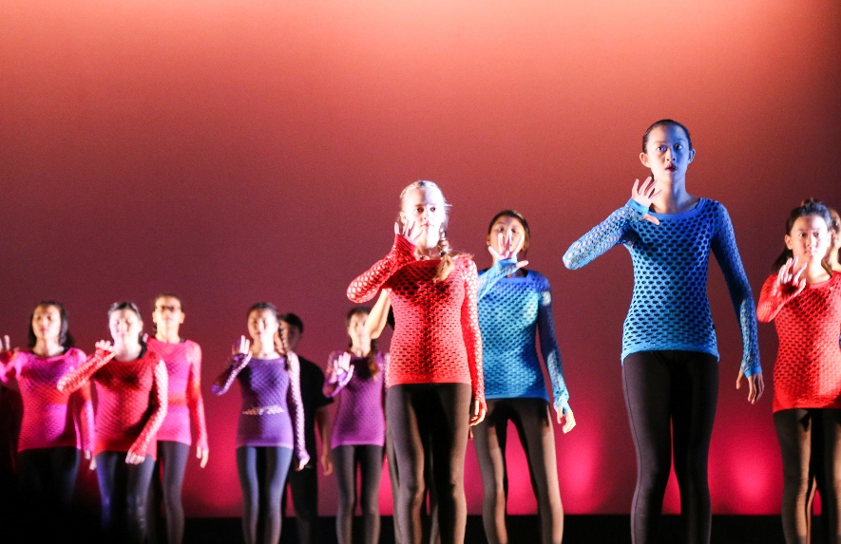

MS Musical: The middle school musical attracts a variety of students who either want to participate on-stage as an actor, back-stage as part of the sound, lighting, construction and make-up crew or in the pit orchestra. Rehearsals are after school and on select Saturdays.
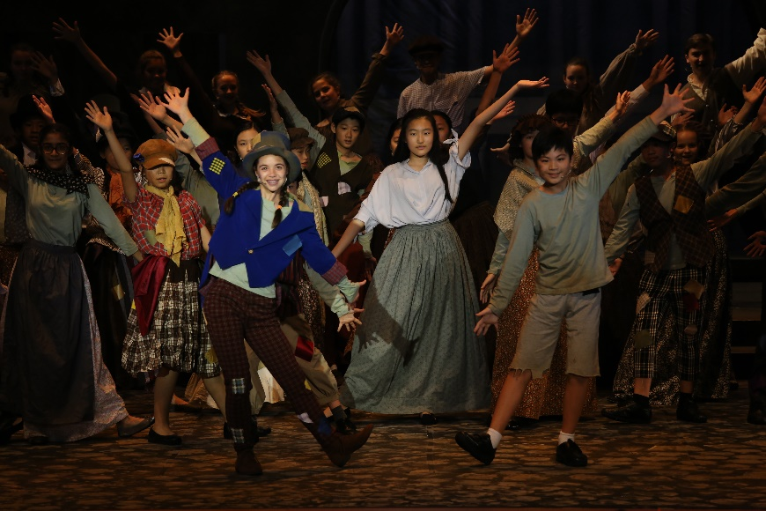

Odyssey Club: A scientific journey full of exciting challenges beyond the classroom! Meets every Wednesday during Blocks 2 and 3. Every meeting is a new adventure. Often, the experiments or challenges we try are suggested by students.
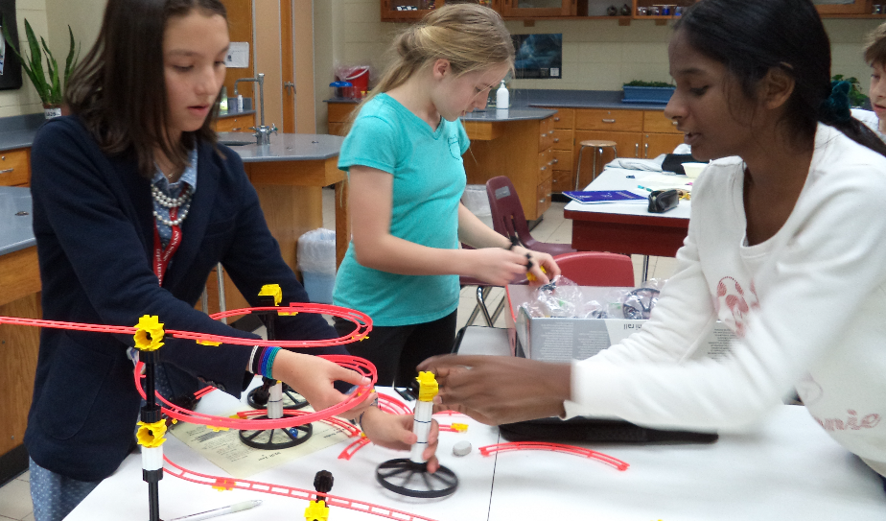
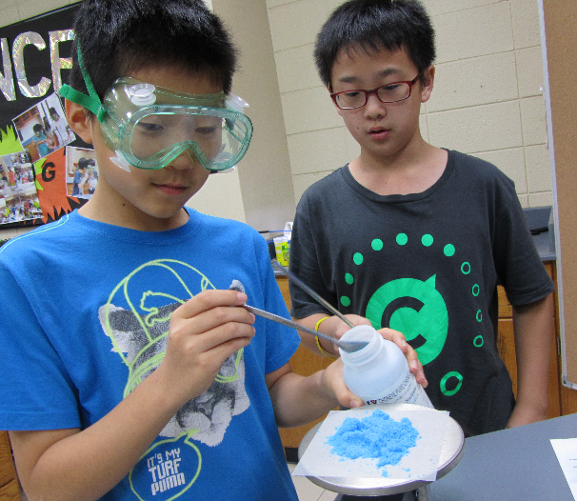

The Orphanage Club is the oldest club at TAS and its members give generously of their time in the service of those less fortunate. From tutoring students in English at the Taipei Municipal School for the Visually Impaired, to organizing outings and fun activities for kids in various orphanages like Cathwel and Chung Yi, the Orphanage Club's members are truly altruistic. They also give up free time on weekends to sort, pack and price donated items for rummage sales to support the orphanages: the most recent made 230,000NT$!
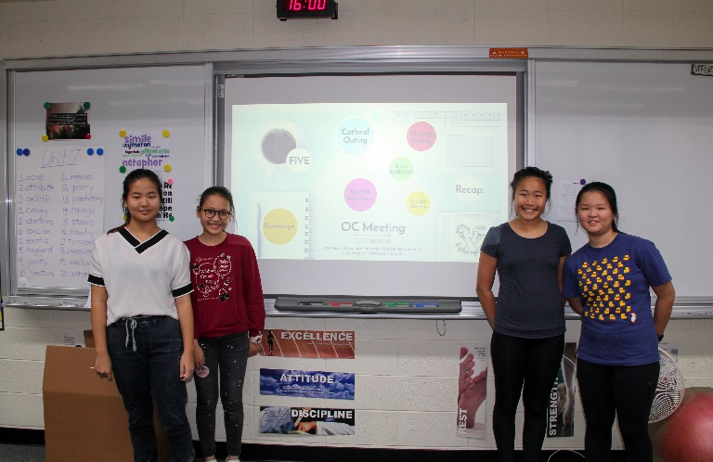

The MS Growl club publishes the online magazine of the middle school. Original comics, stories, poetry, and articles are added each week. The club members write content, post to the website, and serve as the editorial board to determine if pieces from the school community will be published. You can check out the MS Growl by clicking here.
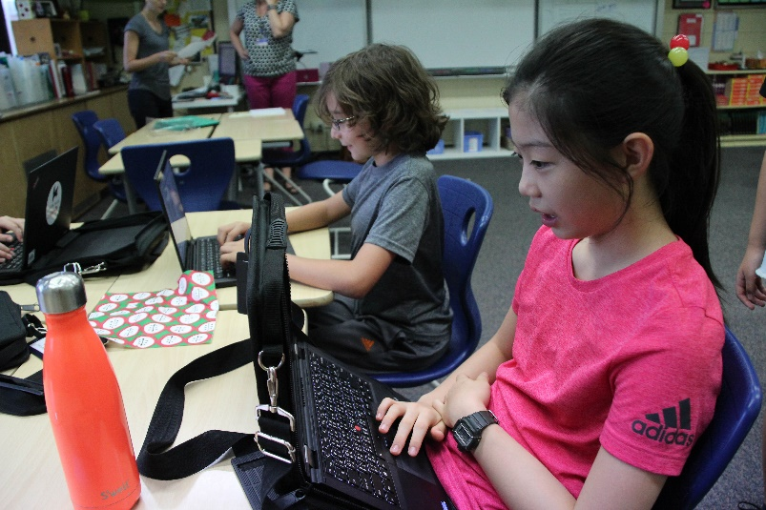

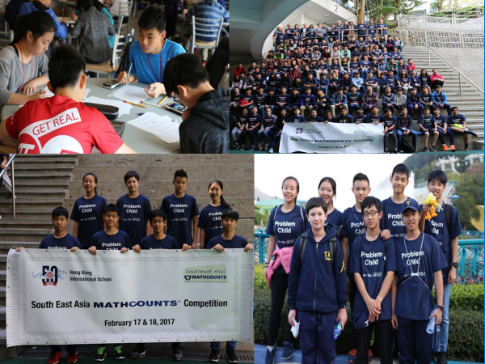
MATHCOUNTS Club is a national program to promote student interest in mathematics. Students build upon everything they learn in class — from algebra to probability — and use it to solve complex problems, apply formulas, and practice drills. This club is not about tedious math work and basic calculations. It celebrates the problem-solving, creative and applied sides of math, where equations and formulas can offer elegant solutions for everyday life. In addition, students are selected to participate in the Southeast Asia MATHCOUNTS Competition and compete for a spot at the National Competition in America in May each year.

The Middle School Yearbook is created entirely by middle school students. Yearbook staff members select the pages they wish to create and are responsible for all steps of page completion from photo-shoots, to photo processing, design layout, final edits, and publishing. Students work collaboratively in this exciting process of archiving everyone's favorite highlights of the school year in this timeless school publication.
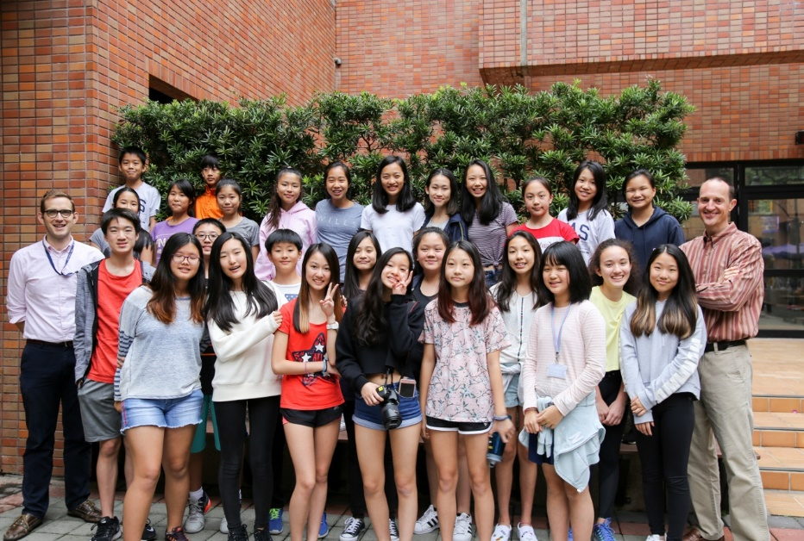
The Middle School VEX EDR & IQ clubs are an incredible opportunity for students to develop skills in engineering, electronics, and programming. We follow the process of design in developing and building competitive robots. Beyond engineering and programming abilities, collaboration is a key skill required of club members. Students must learn to work in a proactive manner with each other on their projects and in competition.
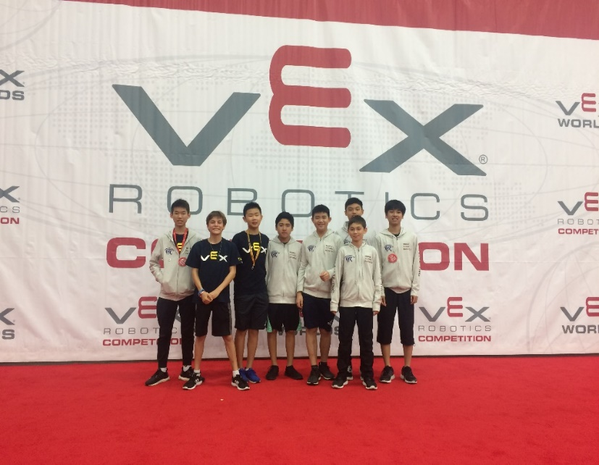
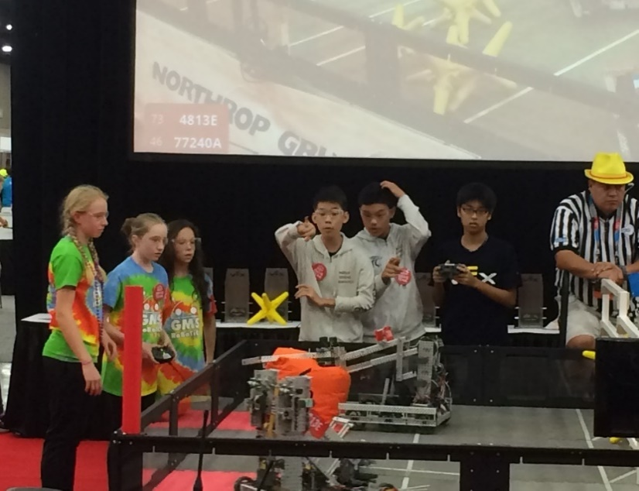
The Friday Game Club provides a social experience for students who wish to drop-in for fun with their friends or to make new friends. We have word games, strategy games, word games, logic games, and card games.
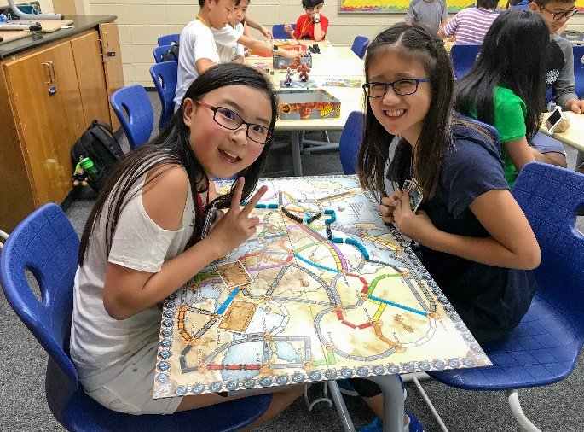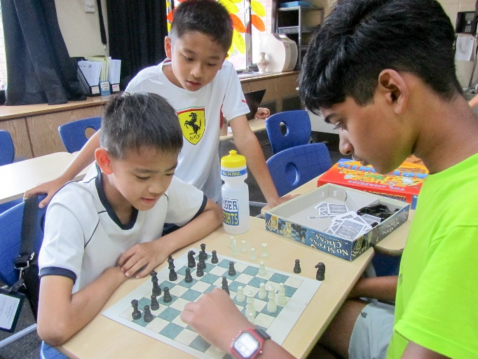
Model United Nations
TASMUN
Model United Nations is a simulation of the real United Nations with students coming together as representatives of different nations to solve global issues through negotiation and debate. MUN is a Grade 6-12 program at TAS that spans multiple debate, leadership, and service opportunities. Middle school students and upper school students work together to develop skills useful throughout their lives such as research and writing, public speaking and problem solving, consensus building and conflict resolution, argumentation and cooperation. The TASMUN team is open to Grade 7 and 8 students. All students who sign up for this team will prepare to attend the Taipei American School conference hosted on campus in late April.
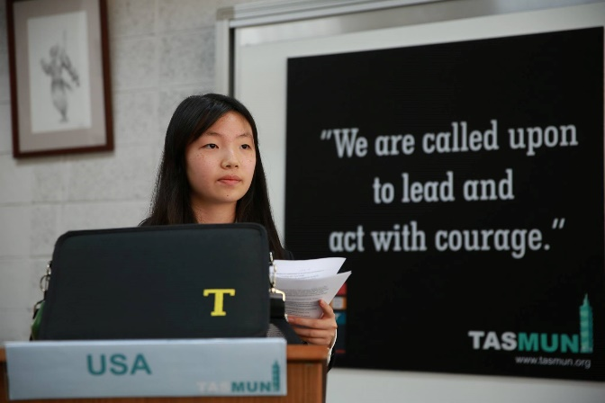
SHASMUN
Model United Nations is a simulation of the real United Nations with students coming together as representatives of different nations to solve global issues through negotiation and debate. MUN is a Grade 6-12 program at TAS that spans multiple debate, leadership, and service opportunities. Middle school students and upper school students work together to develop skills useful throughout their lives such as research and writing, public speaking and problem solving, consensus building and conflict resolution, argumentation and cooperation. The SHASMUN team is open to Grade 8 students selected through an application and audition process. Successful applicants prepare to attend the Shanghai American School Model United Nations (SHASMUN) conference at the Pudong Campus of Shanghai American School in mid-November.
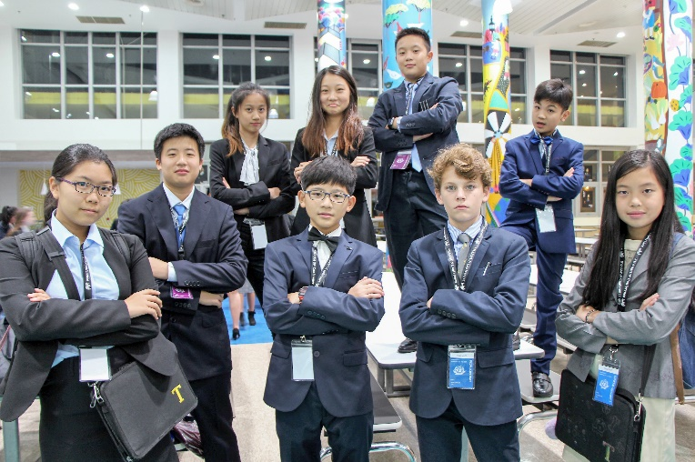
MY-MUNOFS
Model United Nations is a simulation of the real United Nations with students coming together as representatives of different nations to solve global issues through negotiation and debate. MUN is a Grade 6-12 program at TAS that spans multiple debate, leadership, and service opportunities. Middle school students and upper school students work together to develop skills useful throughout their lives such as research and writing, public speaking and problem solving, consensus building and conflict resolution, argumentation and cooperation. The MY-MUNOFS team is open to Grade 8 students selected through an application and audition process. Successful applicants prepare to attend the Middle Years Model United Nations Conference hosted by Overseas Family School (MY-MUNOFS) in Singapore in late February/early March.
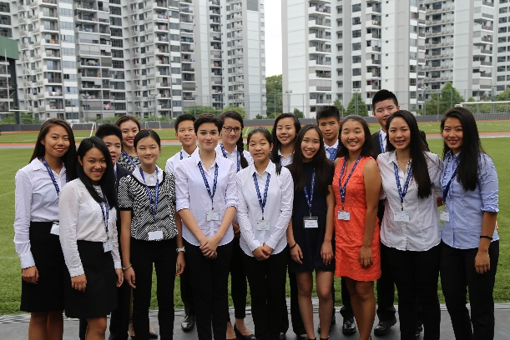
MYMUN
Model United Nations is a simulation of the real United Nations with students coming together as representatives of different nations to solve global issues through negotiation and debate. MUN is a Grade 6-12 program at TAS that spans multiple debate, leadership, and service opportunities. Middle school students and upper school students work together to develop skills useful throughout their lives such as research and writing, public speaking and problem solving, consensus building and conflict resolution, argumentation and cooperation. The MYMUN team is open to Grade 7 students selected through an application and audition process. Successful applicants prepare to attend the Malaysian Model United Nations (MYMUN) middle school conference hosted by Mont’ Kiara International School in Kuala Lumpur in mid-April.

MUN's Press Team is where journalists are made! We meet once a week and we learn all about MUN, their committees, and we work on writing articles and interviewing delegates, chairs, and guest speakers.
All Press Team members are actively involved in the writing and photographing process of keeping record of the MUN conferences. US students mentor and collaborate with the team weekly.
If you have good listening and writing skills, if you want to be a part of a great team where everyone helps each other, and if you think MUN could be for you in the future, this is your club!

Table Tennis club. Students participating in this club learn the rules and skills of table tennis, and participate in mini tournaments. It is a drop-in club and students are welcome to come and try table tennis with their friends on Wednesday afternoons.
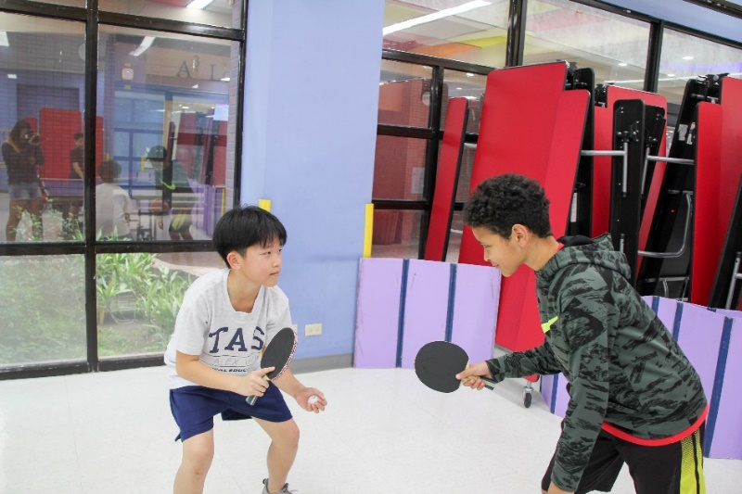
FORUM Club: If you have ever thought that you would rather do anything else than have to speak in public, you are definitely not alone. Middle school forum provides a safe space for students to build confidence and skill in their public speaking while learning techniques in rhetoric’s, research, and argumentation, as well as have fun with numerous speaking games. Many students are new to the events we introduce, and students are taught by experienced high school students who have been through the exact same process, so none should feel inexperienced or scared to participate. Feel free to drop in anytime Friday after school to de-stress from a long week with fun games and build up your confidence and public speaking skills!
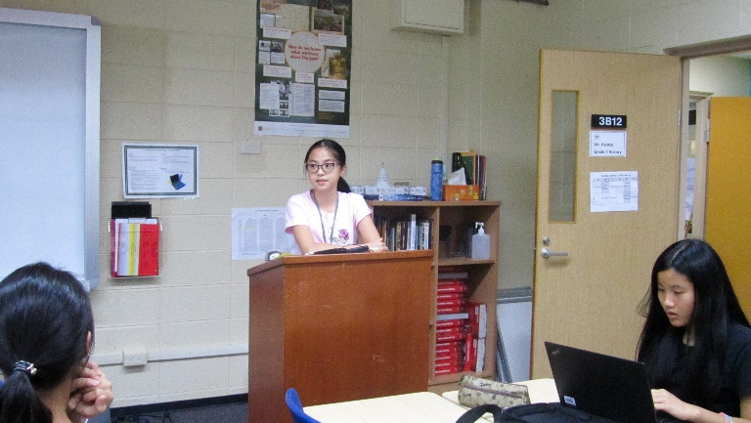

Knots of Love is a drop-in charity knitting club that meets on Wednesdays after school during blocks one and three. Knitting is an easy and fun hobby that involves transforming yarn into beautiful scarves, hats, mittens, blankets, sweaters, and more. Knowing how to knit was once considered a valuable life skill. Nowadays, young people around the world continue to form knitting communities, taking part of this fun, timeless tradition. We provide all the materials and instruction needed to begin knitting. All creations will also be donated to a local orphanage so that other children may enjoy these special hand-knit items made with knots of love.
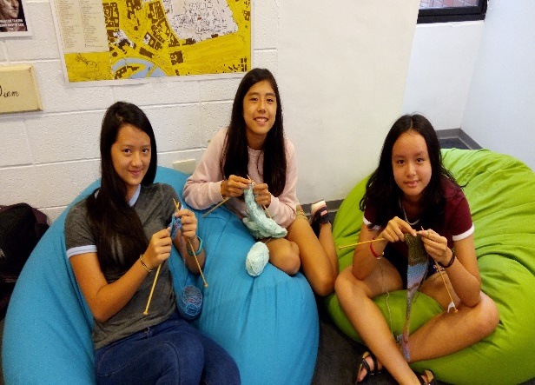

MS Athletic Council is a commit club which supports middle school athletics competitions and events. Members meet briefly each Wednesday before school to sign up to score games or assist with cross country or track meets.
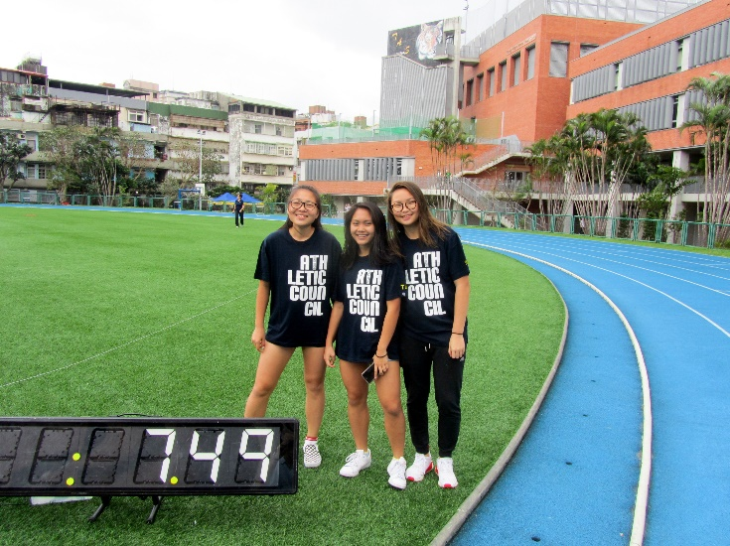

RAD Studio (Robotics. Art. Design)
In RAD studio, students will learn to express creative ideas in art and develop meaningful solutions in design by using a wide variety of tools and techniques. Students will learn to design using Rhino 3D, and Adobe Illustrator and bring their ideas to life through 3D printers, laser cutters, and other tools.

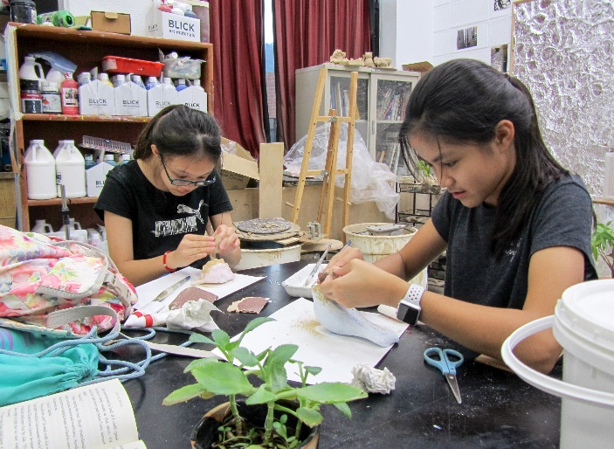

Student Council is a service organization that emphasizes inclusion with a focus on student leadership and service in the TAS, Taipei, and global communities. Students are involved in planning a variety of activities.
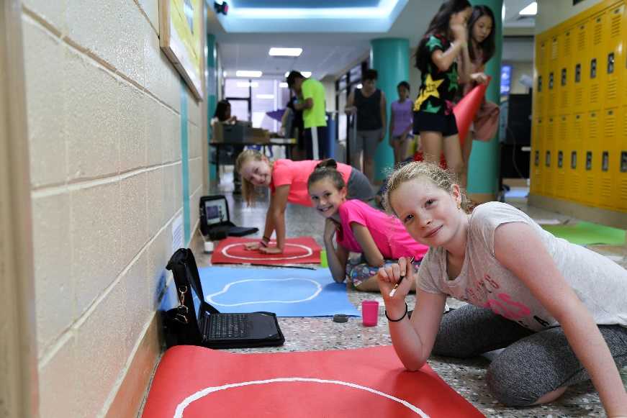

Debate Club: This debate club is for the serious debate student who is committed to attend weekly sessions. Students will learn how to debate using Public Forum Debate methods, and they will develop skills that will be essential and foundational if they are interested in pursuing debate more competitively at the high school level.

Chinese Culture Club: Students get to know and understand the different aspects of traditional Chinese Culture. Members also get hands on experience on how certain Chinese products are made, including cooking delicious snacks.
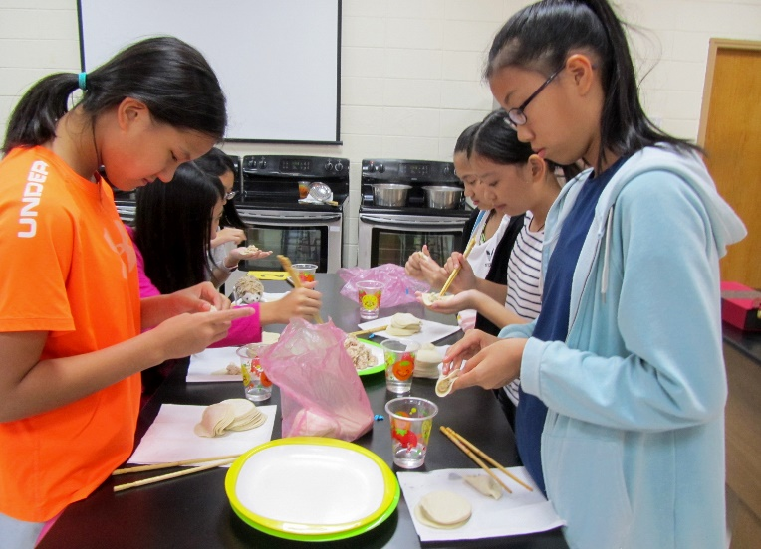

Kiva Club: What does it mean to invest? How does the stock market work? Students will learn about investing and personal finance while also taking part in financial simulation games and supporting micro loans.
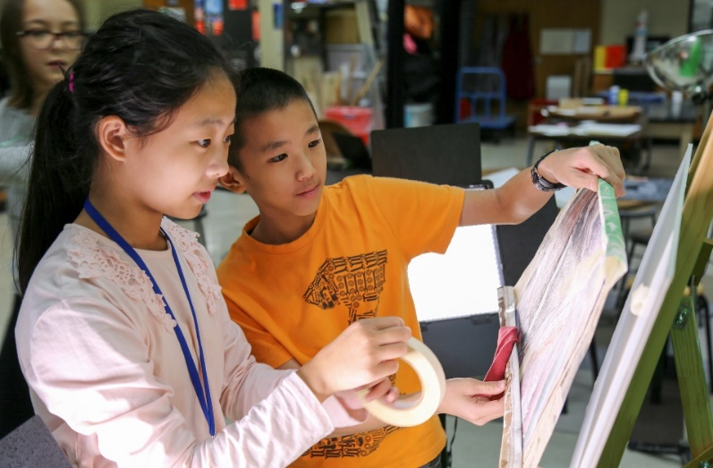

Climbing Club: Climbing walls is a great way to relieve the stress of the academic day. In this club students will learn climbing techniques and how to use climbing equipment.
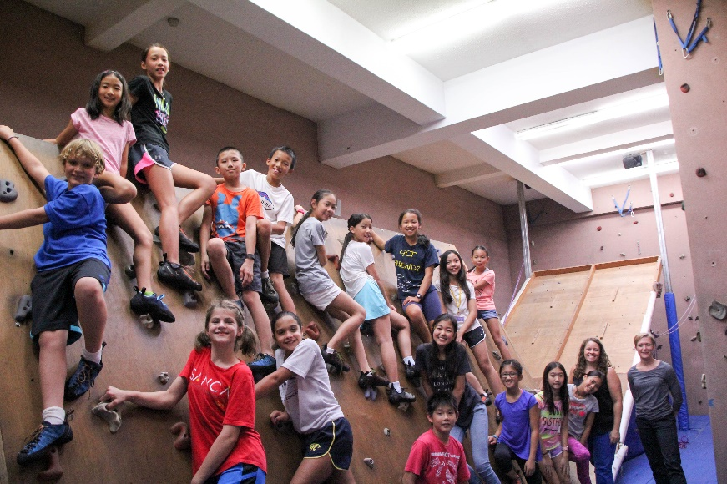

Aviation Club Explorers: The Aviation Club Explorers is a fun and challenging club that meets each Wednesday after school. All students, new and returning, learn to fly several types of radio controlled aircraft including quadcopter drones, airplanes, and helicopters. All training starts with building skills flying a variety of aircraft on high-tech flight simulators. Club members are provided with increasingly more challenging flying opportunities as their skill levels increase including flying with first-person view (FPV) goggles. All flying takes place in designated areas under direct teacher-supervision during regularly scheduled meeting days. Other flying opportunities may exist before school and select Saturdays.
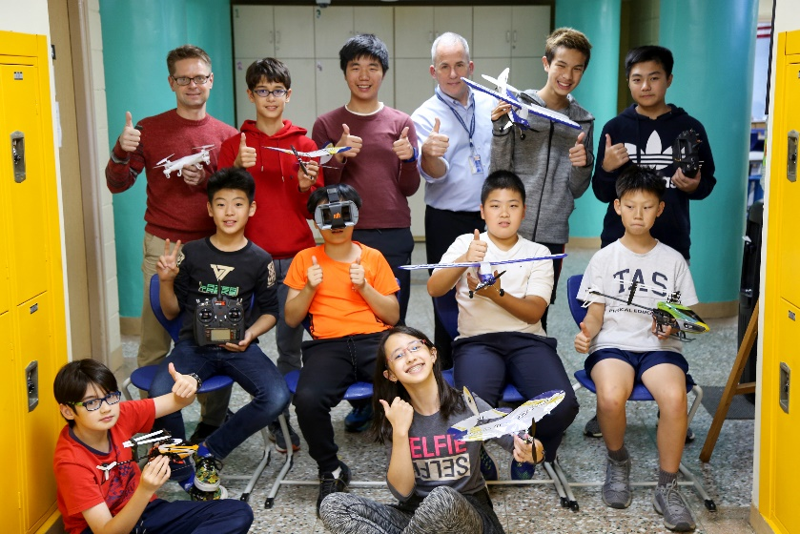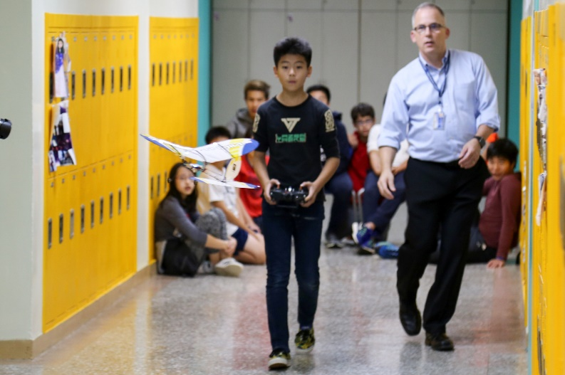

Guitar/ Ukulele Club: Students learn to play basic chords and eventually some of the simpler songs they love to listen to. If you want to be a rock star this is the club for you.

Hip-Hop Dance Club: Everyone loves to dance, students in this club will learn cool hip-hop dance moves and fun dance routines.

REM (Remote English Mentoring) Club: Students in this service club work remotely using I-pads to teach students in Taiwan who do not have access to English language learning opportunities.

Student Ambassadors: Students will assist and welcome students new to TAS, help with ushering duties at TAS events and parent conferences.

Roots and Shoots: Jane Goodall's "Roots and Shoots" is a club that challenges students to design and lead projects that support people, animals, or the environment. Students come up with an idea, register it on the "Roots and Shoots" website, and then make it happen. Examples of projects that students around the world and at TAS have completed include collecting and recycling mobile phones for the needy, raising awareness and money to support endangered or neglected animals, and supporting rooftop gardening projects. ​
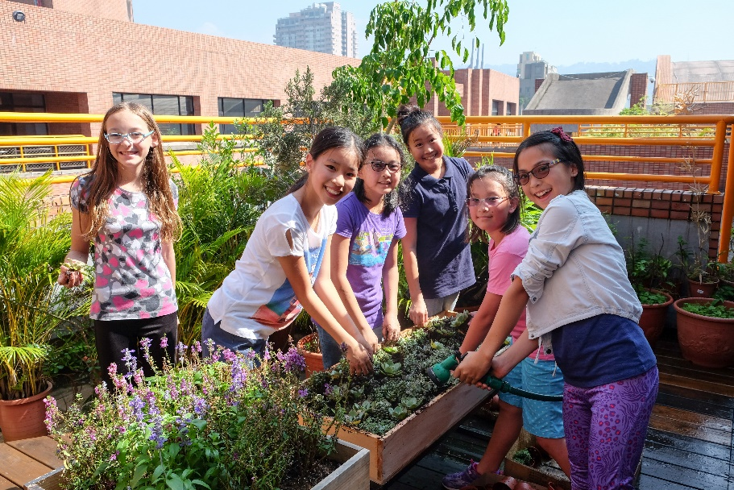
Tiger TV: Tiger TV is a great place for students to learn and practice the skills of creating and producing videos. Whether they like to work behind the camera or in front of it, or both, students can develop their creativity while making videos to keep other students informed about the Middle School's great activities!
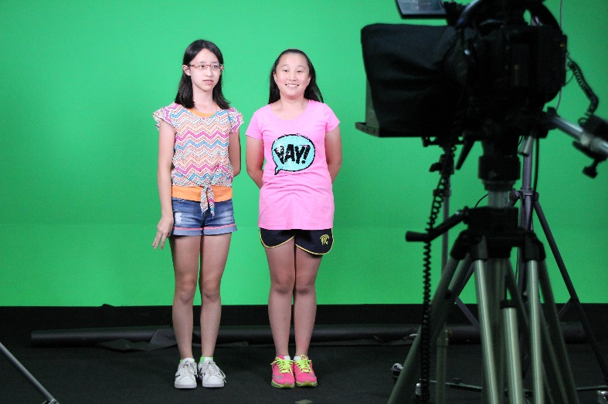

Code to Create:
In the Code to Create club members club members become familiar with programming logic/patterns and the Python language through the CodeCombat.org site. Students will undertake projects, for example recently members started to work on building a smart mirror using a Raspberry Pi. If you like to code this club is for you.

