How to login TAS parent portal?
Note: Currently, TAS had integrated both PowerSchool parent portal and Tigernet parent portal, so which mean you only need to login one of both portals then the other one will directly login.

Step1. Go to the TAS school website (Tigernet) as below.
https://www.tas.edu.tw

Step2. Click or Hover the COMMUNITY
- Click the Community, and it will redirect you to login page as below and click the PARENT LOGIN
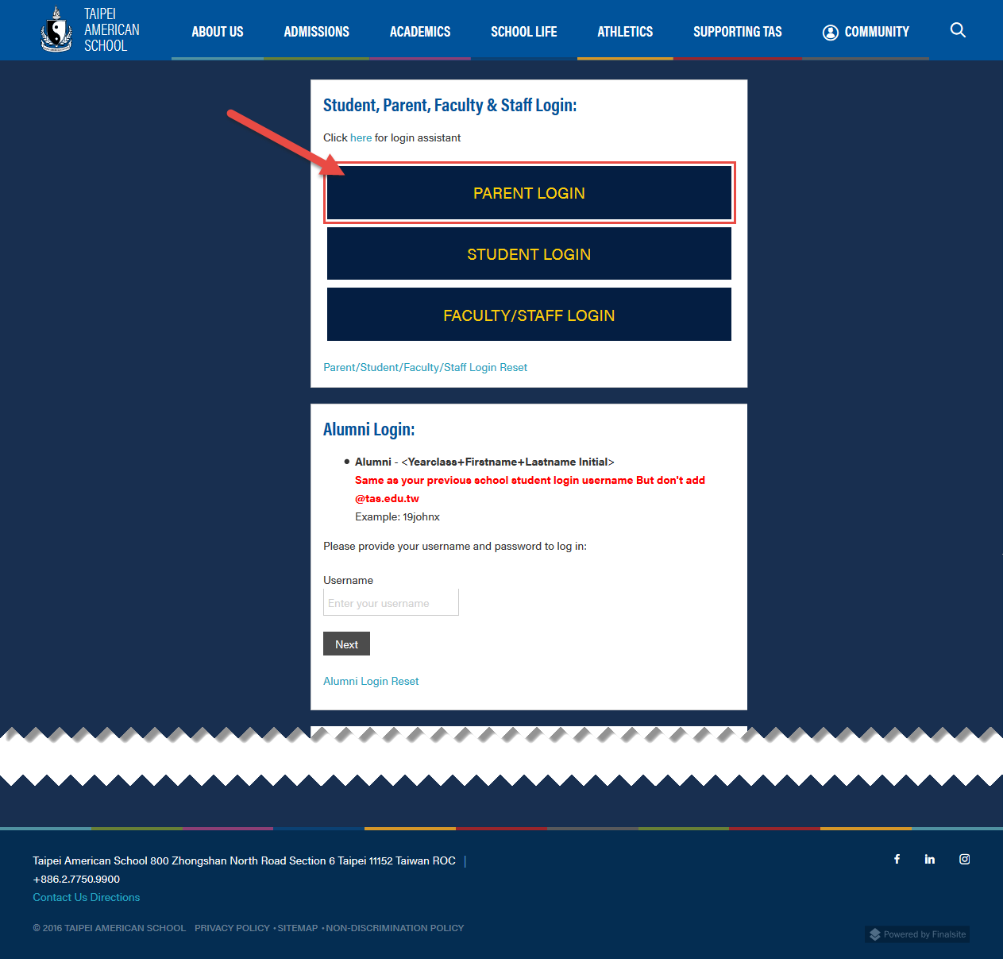
- Hover the Community, It will show the drop-down list of each difference portals. Click Parents

Step3. It will redirect you to the login page as below.
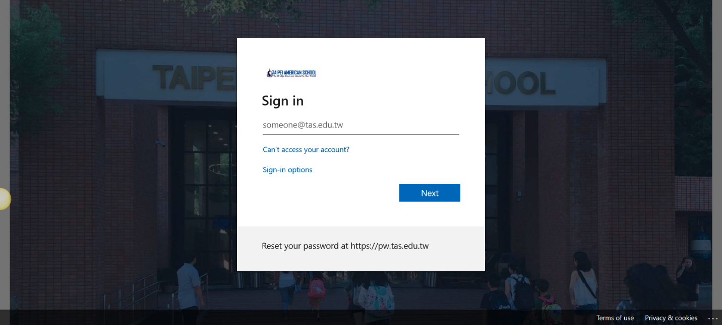

Step4. Type in your username by using Tiger Tag
Enter your username and password (same as your ​PowerSchool Username/Password​).
For TAS parent, Your username will be Parent ID with Tiger Tag (@tas.edu.tw). For example, if your Parent ID is P1234567, the username will be ​P1234567@tas.edu.tw​ for log in.
For TAS Employees is ​your networked computer login account adding @tas.edu.tw​. Like Employee@tas.edu.tw
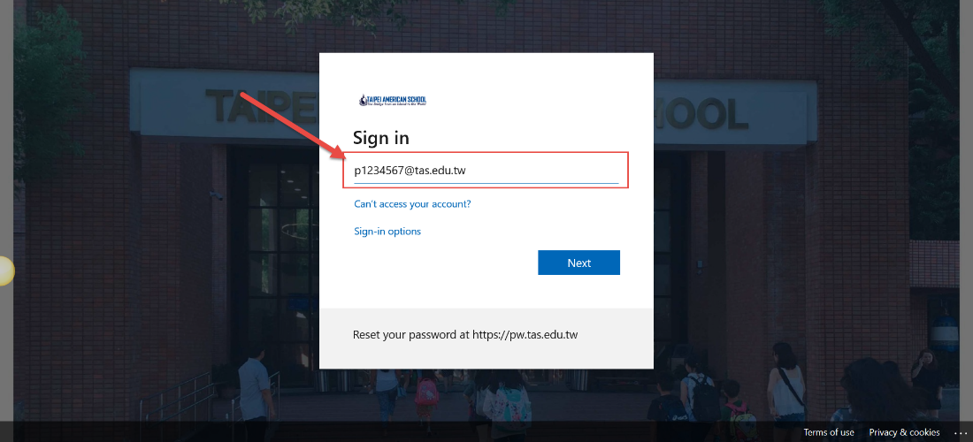

Step5. Type in your password
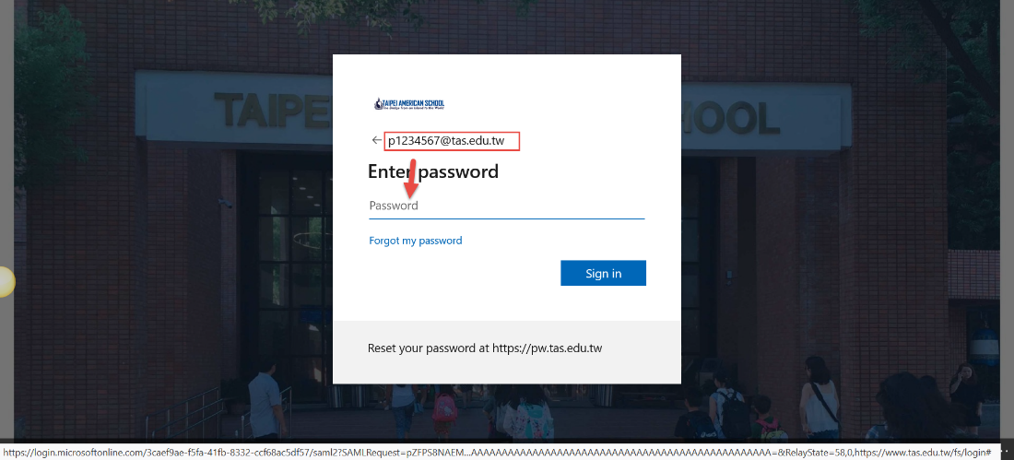

Step6. Once you successfully login, It will take you to the Tigernet Parent Portal

Step7. Go/Switch to the PowerSchool Parent Portal, click the PowerSchool Parent Portal link as below.
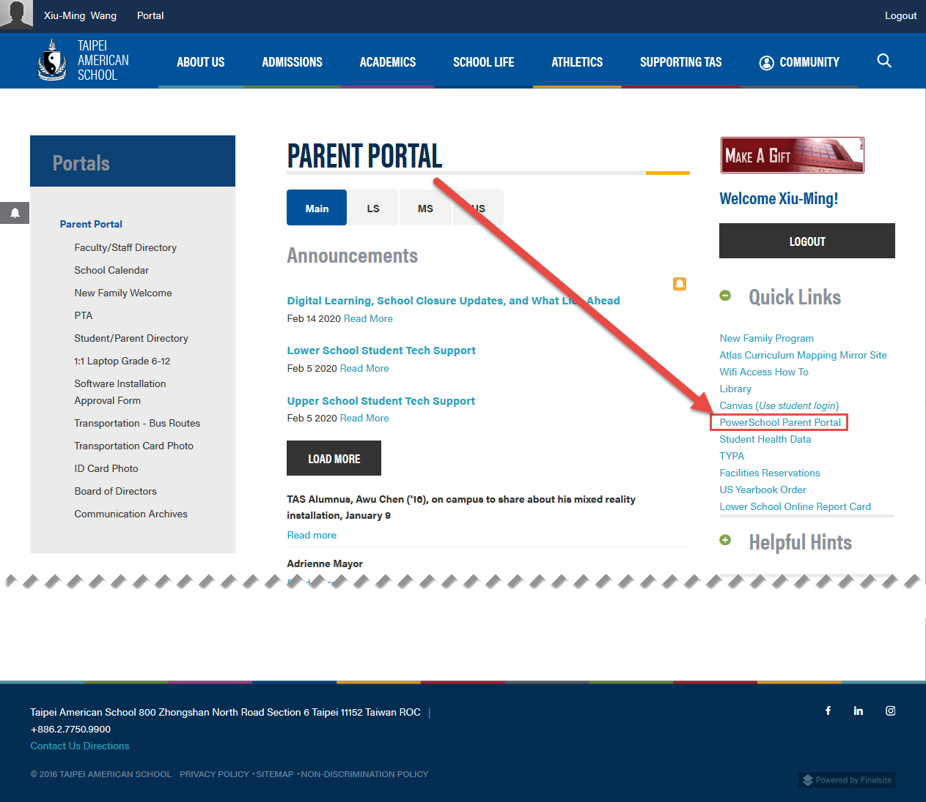

Step8. It will redirect your page to PowerSchool Parent Portal login page. Click the Parent Sign In then It will directly login to parent portal without asking your username/password (step3,4,5) again.
